MEMS 1043
Senior Design
Spring 2025

Milestone III

Design Validation

Robot-Assisted Construction of Fibrous Materials

Dr. Ian Sigal

Team Members and Roles

Coordinator Karan Choudhari kac518@pitt.edu Planner James Puzon jlp57@pitt.edu
Resource Manager Logan Radomicki clr107@pitt.edu
Resource Manager Lowell Shaw lhs26@pitt.edu
Presenter Max Mongiello mjm459@pitt.edu

1. Supporting Analysis

Analysis Approach

Our validation approach will be a comparison of final work products with the requirements and specifications listed in our Milestone I document. Since each of these includes a validation method, these can be followed to assess how effective the final designs are.

Relevant analysis will be conducted as follows:
- Mechanical Design II (MEMS 1029) - Gear stress analysis for specified loading conditions
- Mechatronics (MEMS 1049) – Selection and design of motor/motor controller
- Electrical Circuits (MEMS 0031) – Calculations for voltage splitter selection and issues in final design

Analysis

- Acetal Gears theoretically evaluated for stress in gear the gear teeth using Lewis’ equation for bending strength of gear teeth. F.o.S under maximum torque output of stepper motor for system >10. Design survives practical testing under realistic stepper motor loading.
- Mechatronics Layout:
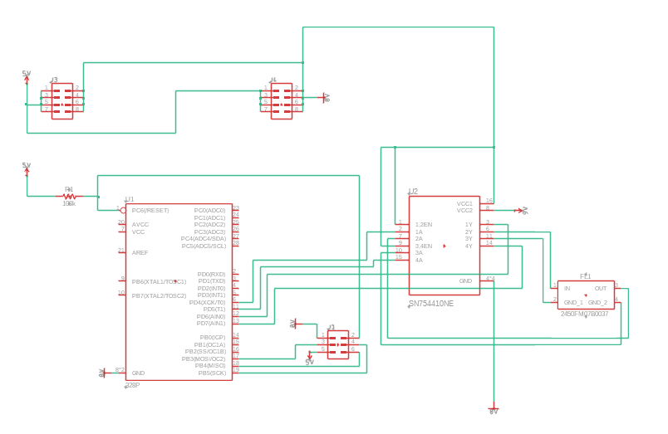

Requirements and Specifications

Requirement | Method of Validation
End effector must mount on a standard bots RO1 | Experimental: Does it mount and stay connected?
Must dispense fiber under tension | Experimental: Is fiber dispensed by moving the end effector away from a fixture point? Fiber should appear as a straight line and not sag.
Survive abrasion by fiber, and not abrade fiber too much | Experimental: Is fiber visibly damaged or frayed?
Tension should not be more than the robot, nails, or end effector can handle | Experiment analysis: Is the end effector able to lay down yarn without disrupting the base structure?
Start and end fiber without human assistance | Experimental: Can the robot fix fiber to a starting point? Can it fix fiber to an endpoint and snip the remaining thread?
Hold enough fiber to not require replacement during operation | Experimental: Can the robot complete structures without finishing a spool?
Be able to create 3D fiber structures | Experimental: Can the robot recreate the previous team’s bridge? Can it build some more elaborate structure?
Needs to be able to fix fiber to a point, and continue the fiber afterwards | Experimental: Can the robot build polygonal chains by attaching fiber to a starting point and winding it between some number of midpoints?
Minimize the size of the end effector tip, to allow for higher-resolution structures | Experimental: Is the end effector colliding with nails or already-placed fibers?
Adapt to different structures –should be able to make anything programmable | Experimental: Does the robot require extensive troubleshooting every time a new structure is attempted? It shouldn’t.
Wrap dispensing fiber around a pre-existing stationary fiber, creating a ‘woven’ joint. | Experimental: Can the end effector create a woven joint without getting stuck or damaging the pre-existing structure?

Specifications | Method of Validation
End effector must weigh less than 18kg and conform to dimensions of connecting flange | Physical measurement of weight and dimensions
Be able to reliably reproduce structures at a success rate greater than 70% | Experimental: Measure number of dropped fibers within a structure

2. Archive & Cleanup Plan

Archive Plan

To transfer all project data, we will combine all documents and project files into a single folder that will be shared digitally, as well as on a flash drive. Within these documents, we will also build a summary document highlighting the main parts of the project, and where to find specific information in our documents. A basic summary of our design process will also be described. Lastly, we will include all our emails as well, to provide a direct source of contact for future teams if needed.
CAD files for all end effector prototypes and the connecting flange will be transferred. An assembly guide for the end effector will be included, and potential design changes will also be mentioned. The physical prototype of the end effector will remain on the robot. The final mechatronics setup and a corresponding circuit layout will be turned over, as well as documentation of present issues and potential solutions. Guidance on potential future objectives will also be included.

Clean Up Plan

Resources purchased for our project will be labeled and stored in G26 for future teams to use. As these parts are specific to our prototype, this will reduce costs for building future end effectors. Any prototypes that are no longer relevant will be discarded.

3. Final Deliverables

Our team has three primary deliverables: the final end effector, the clips used for self-stopping, and a model built using the robot arm. Associated CAD files and videos will also be included.
The final end effector allows fiber to be dispensed and woven on-demand by rotating a set of gears, driven by a stepper motor. When attached to the robot, it is capable of building the 3D structures we set out to achieve. While this end effector works mechanically, the motor currently installed is not strong enough to rotate the gears. Additionally, our plan for interfacing between the robot and this motor was never successful; this is the main difference from expected deliverables, and both issues must be addressed in later semesters. Due to the glued construction of the end effector, it is not possible to install a different motor. As this will require a new end effector to be built, assembly instructions will also be included in final documentation.
Clips used for self-stopping can successfully hold fiber, but do not address start functionality and may not work if fiber tension is too low. Due to the clip being too narrow, fiber cannot be inserted. If the force required to bring fiber into the clip is higher than the force required to dispense new fiber from the end effector. This issue and the lack of start functionality are the main differences from expected deliverables.
The 3-D fiber model incorporated fiber dispensing but could not use weaving due to issues with the end effector motor, as described earlier. Programming with the arm’s proprietary software was also more limited than we initially expected. As such, we recommend that future projects switch to an API that can make use of forward and inverse kinematics for programming. The lack of weaving in the final model and limits with programming are the only gaps between expected deliverables.
While there are certainly issues present, our sponsor considers this project successful. We were able to design a new end effector to accomplish weaving and then program the arm to recreate structures similar to the ones built by previous teams. This meets the minimum goal (build a structure with the new arm and end effector) set by our sponsor and achieves one of the two challenge goals (weaving or start/stop)

4. Design Validation

The primary method of validation for our project is the form of a physical 3D base structure upon which the end effector lays down string in a predetermined path to create a woven yarn structure. This structure was intended to demonstrate fiber-laying and weaving. Due to issues with the end effector’s driving motor, this structure was able to demonstrate the fiber-laying to the sponsor but was unable to perform weaving. However, when additional power was supplied through a function generator, the end effector can mechanically weave. This shows that a future adapted model with the proper motor will be capable of achieving the project’s primary objective.

The following is a list of unfulfilled requirements and specifications:

- Start without human interference was not implemented. Project sponsor approved of narrowing scope after providing a broad range of potential goals, leaving room for future project iteration. Design concepts for start insufficiently refined for robust.
- Weaving was not achieved due to the issues with insufficient motor torque output. Providing the additional power allowed for weaving to occur, the robot is incapable of supplying that level of power.

